**Quantitative result**

Method: **Normal Particle filter**, Particle size: 500, Crop size: 50x50

Comparison metric: Norm between the closest particle and the drone position

Time vs Performance

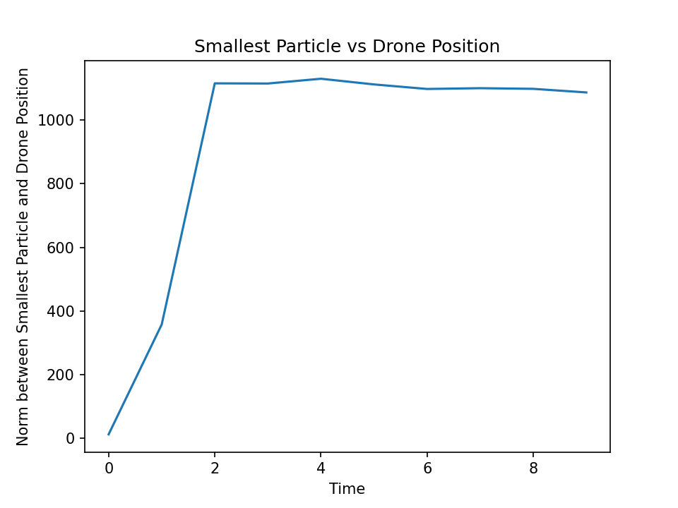

Final distance: 1086.257709366359

Method: **Normal Particle filter**, Particle size: 500, Crop size: 75x75

Time vs Performance

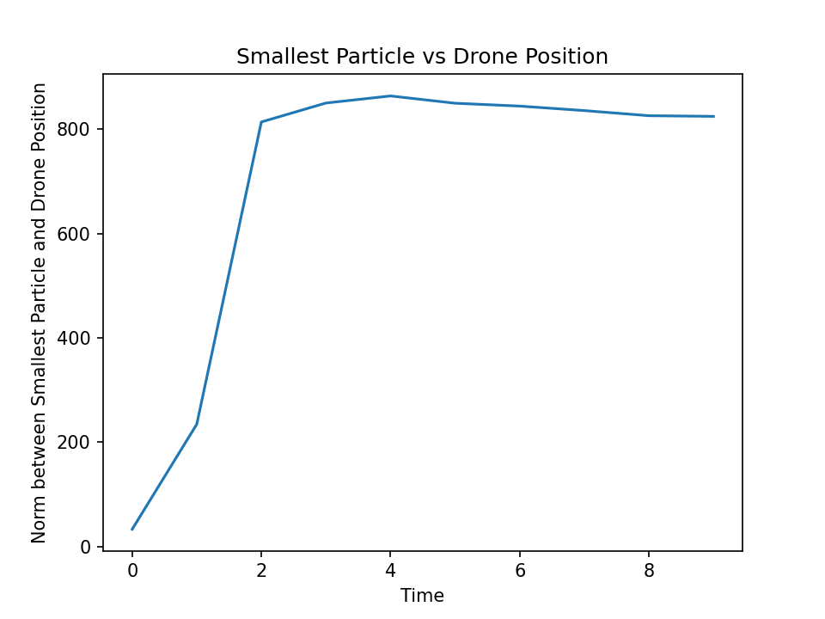

Final distance: 824.3261927699253

Method: **Particle filter with color histograms**, Particle size: 500, Crop size: 50x50

Time vs Performance

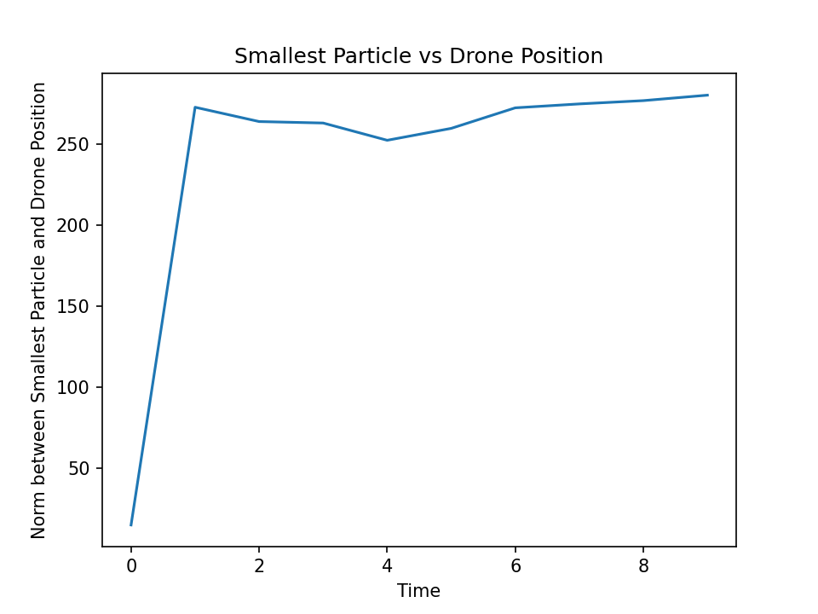

Final distance: 279.97645806458394

Method: **Particle filter with color histograms**, Particle size: 500, Crop size: 75x75

Time vs Performance

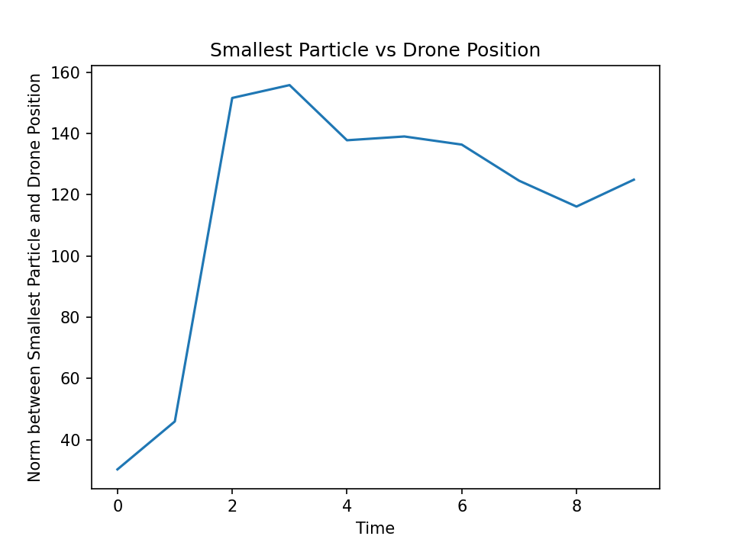

Final distance: 124.94851043757917

Method: **Particle filter with color histograms and adding noise to sensors**, Particle size: 500, Crop size: 75x75

Time vs Performance

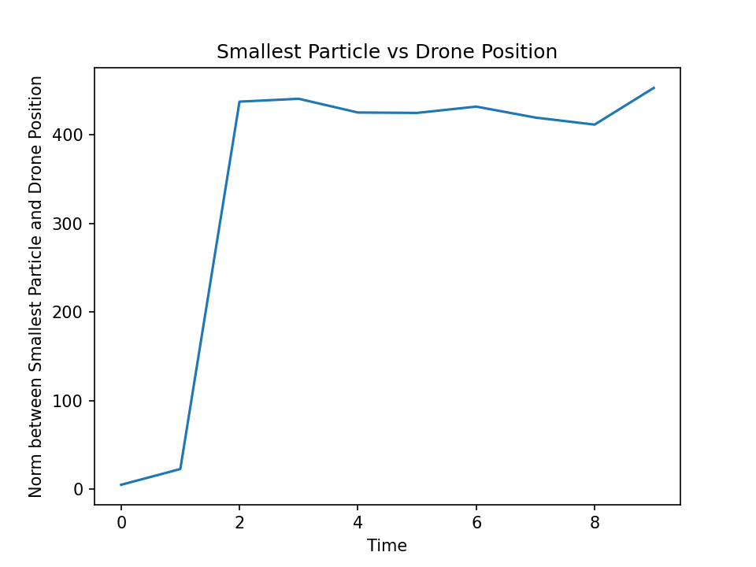

Final distance: 452.7752216322133

Method: **Particle filter with color histograms and adding noise to images**, Particle size: 500, Crop size: 75x75

Time vs Performance

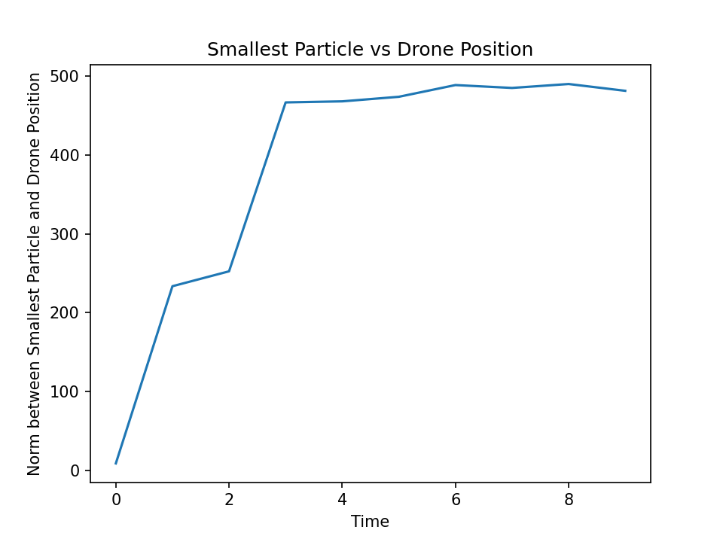

Final distance: 481.4109152180006